



MIDDLE EAST TECHNICAL UNIVERSITY

Electrical & Electronics Engineering Department

EE463 Static Power Conversion I Hardware Project

Complete Simulation Report

Group 5
Yiğit AKYOL 2515484
Ahmad Parwaiz Qoram 1907336 Ismayil Ibrahimli 2489060

- Introduction
The interface between the AC utility grid and DC industrial machinery requires reliable power conversion stages. In this project, the team aims to design a controlled rectifier circuit to drive a 5.5 BHP DC motor. This report details the systematic approach taken to achieve this goal, documenting the progression from a theoretical problem to a hardware solution.
The study initiates with a comparative review of three distinct topologies: the three- phase diode rectifier with a buck converter, the single-phase thyristor rectifier, and the three- phase thyristor rectifier. Following a trade-off analysis, the most applicable topology is selected for further development. The subsequent sections present the analytical derivation of voltage and loss equations, followed by verification via simulation. The final section is dedicated to the selection of power semiconductors and passive components based on simulation data.

Project Description and Problem Statement
  - Project Description
The primary objective of this project is to design a controlled rectifier capable of driving a DC motor. The design must bridge the gap between the AC supply and the DC motor's requirements. Specifically, the driver circuit must accept a single-phase or three-phase AC input and deliver a controlled DC output that does not exceed a maximum of 180V DC.

Project Specifications
The design is constrained by the specific electrical and mechanical parameters of the DC motor to be driven. The parameters for the target motor are listed below:
- Rated Power (BHP): 5.5
- Rated Speed: 1500 RPM
- Rated Voltage: 220 V
- Rated Current: 23.4 A
- Armature Winding: 0.8 Ω, 12.5 mH
- Shunt Winding: 210 Ω, 23 H
- Interpoles Winding: 0.27 Ω, 12 mH

- Topology Comparison and Selection
  - Comparison of the 3 considered Topologies
    - Three Phase Diode Rectifier with Buck Converter
This is a two-stage process. First, a diode rectifier converts AC to DC, and then a buck converter steps down the voltage.
It provides a DC output with decreased ripple and is generally less expensive than thyristor topologies.
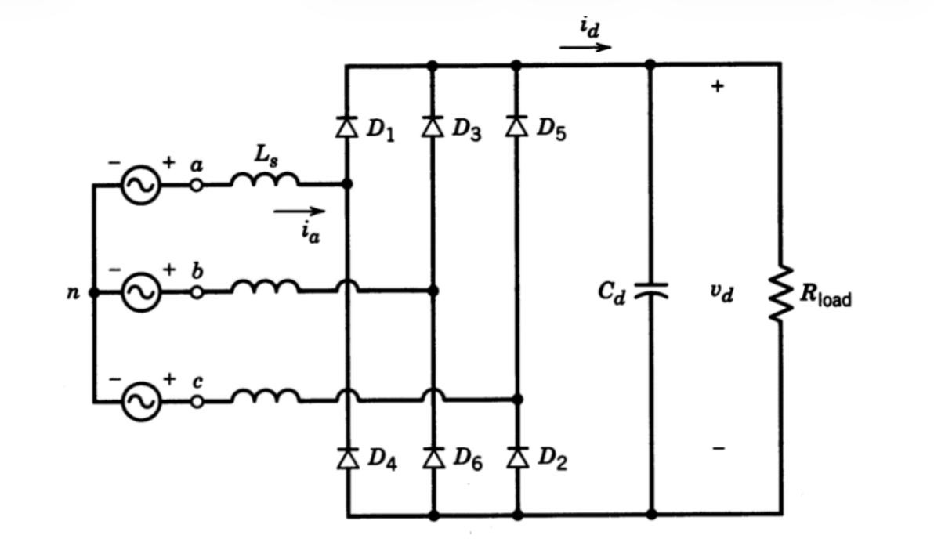
Figure 1: Three Phase Diode Rectifier schematic
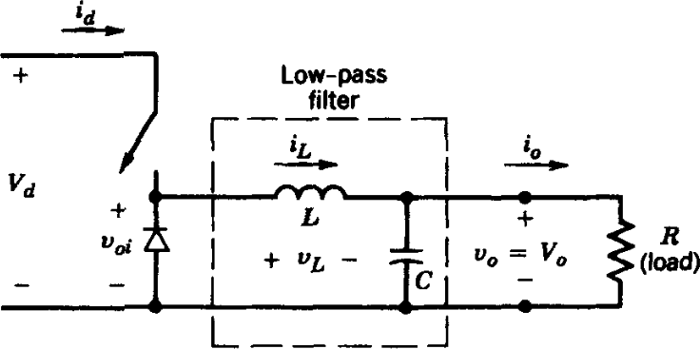

Figure 2: Buck Converter schematic

Key Equations:
      - Rectifier Output: Vav=(3*sqrt(2))/π*Vll
      - Buck Output: Vout=Vin⋅D , where D is the duty cycle. Advantages:
      - Reduced Ripple: It takes grid AC voltage as input and provides a DC output with decreased ripple compared to pure rectifier circuits.
      - Cost-Effective: Although it consists of two distinct parts (rectifier and converter), this topology is generally less expensive than topologies that rely heavily on thyristors.
      - Simpler Control: Only one component (the switch in the buck converter) requires a gate signal. This makes the circuit layout and signal synchronization much simpler than thyristor-based topologies where every switch needs precise timing.
Disadvantages:
      - No Inverter Mode: This topology cannot operate in inverter mode (regenerative braking). Energy flows only one way, from source to load.

Single-Phase Thyristor Rectifier
Uses four thyristors to rectify single-phase AC to DC. The output is controlled by changing the firing angle (α).
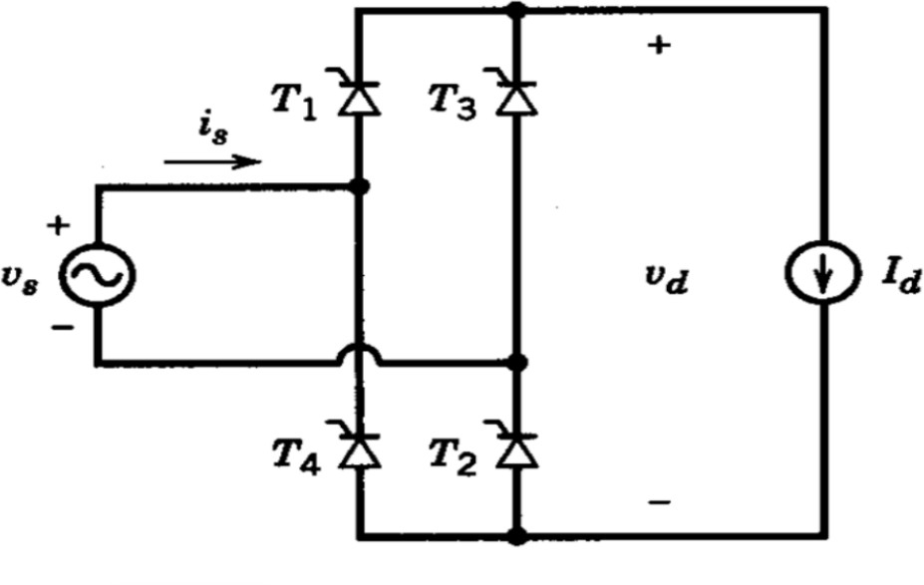

Figure 3: Single-Phase Thyristor Rectifier schematicKey Equation:

Output Voltage: Vav=(2*sqrt(2))/π*Vphcosα Advantages:
      - Full Control: The output voltage can be fully controlled via the firing angles.
      - Inverter Capability: Unlike the diode/buck topology, this circuit can operate in inverter mode, allowing for regenerative braking.
      - Simpler than 3-Phase Thyristor: Since it uses only four thyristors, the circuit layout and gate signal synchronization are simpler than the three-phase thyristor version.
      - Cost vs. 3-Phase: It is less expensive compared to the three-phase thyristor version because it requires fewer components.
Disadvantages:
      - High Ripple: The output voltage ripple is high, which may require larger filtering components.
      - Harmonics: It causes harmonic problems in the input current.
      - Lower Voltage: The average output voltage is lower than the three-phase version.
      - Complexity vs. Diode: To drive the thyristors properly, driver circuits are needed. This increases the layout complexity and component cost compared to the diode/buck option.
      - Higher Cost: It generally costs more than the three-phase diode rectifier with a buck converter.

3.1.3. Three-Phase Thyristor Rectifier
Uses six thyristors. It offers smoother power delivery than the single-phase version.
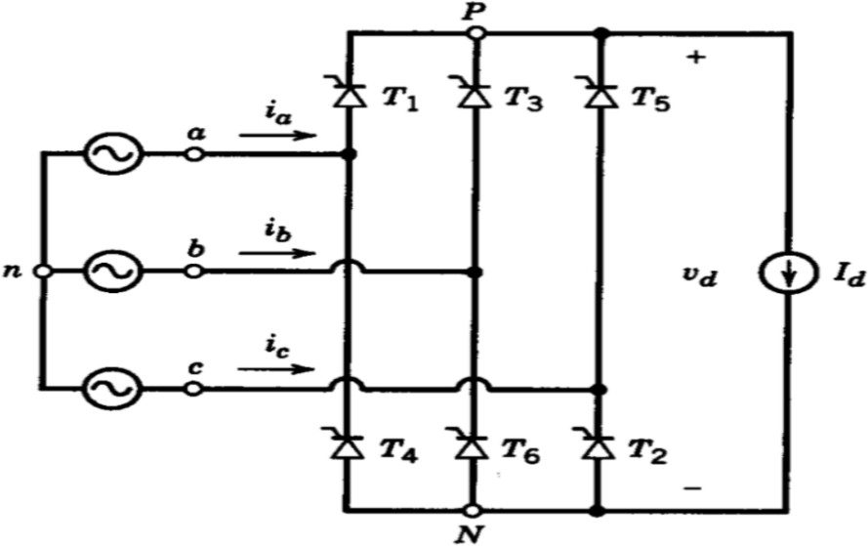
Figure 4: Three-Phase Thyristor Rectifier schematic

Key Equation:
Output Voltage: Vav=(3*sqrt(2))/π*Vphcosα Advantages:
- Low Ripple: This topology results in a lower output ripple voltage compared to the single-phase case.
- High Voltage: The average output voltage is higher than the single-phase equivalent.
- Full Control: Like the single-phase version, the output voltage is fully controlled.
- Inverter Capability: It is possible to use this topology in inverter mode for regenerative braking.
Disadvantages:
- High Cost: Since six thyristors are used, it is the most expensive option.
- Complex Control: As the number of thyristors increases, the complication of generating gate signals increases as well.
- Synchronization: Synchronization of the firing signals is harder to achieve.
- Driver Requirement: The gate signals must be provided through driver circuits, which increases both complexity and cost.
- 3 different topologies are listed in table 1. From the aspect of both THD and output voltage 3 phase topologies are advantageous.

Table 1: Topology Comparison Table

Topology type | THD of IIN | Vout,rms | Number of elements
3 phase diode rectifier  + buck converter | ≈ 40% | (3*sqrt(2))/π*Vll*D | 7 diodes+ 1 MOSFET+gate driver+passive elements
single phase controlled rectifier | ≈48.5% | (2*sqrt(2))/π*VIN*cos(a) | 4 thyristors+gate driver+passive elements
3 phase controlled rectifier | ≈31% | (3*sqrt(2))/π*Vll*cos(a) | 6 thyristors+gate driver+passive elements

  - Topology selection
After researching and comparing the available options, the team has decided to proceed with the Three-Phase Diode Rectifier with a Buck Converter. This decision is based on the following key factors:
- Output Quality: This topology takes the grid AC voltage and converts it to a DC output with significantly decreased ripple. This stable voltage is crucial for the efficient
operation of the DC motor.
- Control Simplicity: Unlike the thyristor-based topologies which require complex synchronization for multiple switches, this design requires a gate signal for only one component (the switch in the buck converter). This makes the control circuit design much simpler and more robust.
- Cost-Effectiveness: Even though it involves two stages (rectifier and converter), this solution is less expensive than the topologies that rely on multiple controlled thyristors.
- Design Trade-off: While we acknowledge that this topology is not suitable for
operating in inverter mode, the benefits of lower cost, reduced ripple, and simpler implementation outweigh the need for regenerative braking in this specific project scope.

Mathematical Calculations and Simulations
Considering the project requirements, the maximum DC input voltage of the DC motor is 180 V, Vout,max=180 V. For this reason, we chose a maximum duty cycle of 0.8, Dmax=0.8, to satisfy the limitation of the DC voltage, because higher duty cycle values are challenging to achieve. Nominal DC voltage that the three-phase diode rectifier must supply is calculated as below.

𝑉𝐷𝐶,𝑟𝑒𝑐𝑡 =
𝑉𝑜,𝑚𝑎𝑥

𝐷𝑚𝑎𝑥
180
= = 225 𝑉 0.8

Using the average DC output voltage of a three-phase diode rectifier, we must calculate the input three-phase voltage needed to satisfy the requirements. The calculations are below for this process.
𝑉𝐷𝐶,𝑎𝑣𝑒𝑟𝑎𝑔𝑒 = 1.35 𝑥 𝑉𝐿𝐿
𝑉𝐷𝐶,𝑟𝑒𝑐𝑡

𝑉_{𝐿𝐿} =
166.7
𝑉𝑝ℎ𝑎𝑠𝑒 =
√3
= 166.7 𝑉
1.35
= 96.5 𝑉 𝑎𝑝𝑝𝑟𝑜𝑥𝑖𝑚𝑎𝑡𝑒𝑙𝑦

𝑉_{𝑝ℎ𝑎𝑠𝑒,𝑟𝑚𝑠} = 96.5 𝑥√2 = 136.1 𝑉

Therefore, it is concluded that a phase rms voltage of 136.1 V must be used to obtain the DC output that will be used to drive the motor.

Three-Phase Diode Rectifier Simulation
In the simulations of the three-phase diode rectifier, a phase rms voltage of 136.1 V with ±120° phase differences, six nearly ideal diodes, a resistor to obtain an output voltage, and a capacitor with a value of 100 µF are used. The simulation model is shown in Figure 5.
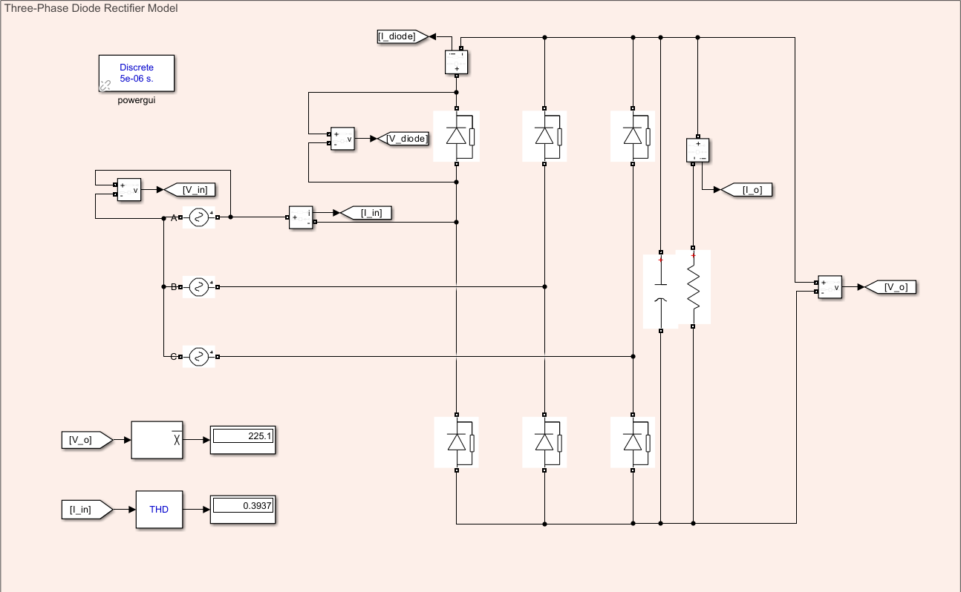
Figure 5: Three-Phase Diode Rectifier Model
Using the simulation model, we simulated the average DC output of the diode rectifier and the THD of the input. Observing the average output, it is concluded that this topology is suitable for obtaining an input to the buck converter. Moreover, the THD value of the input current is also compatible with our requirements.
The output voltage and output current waveforms are shown in Figure 6.

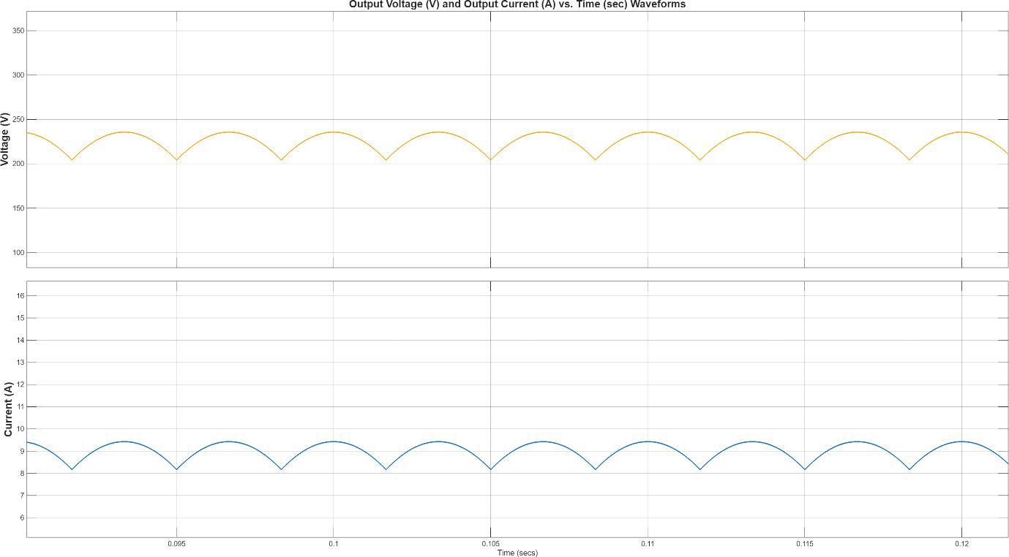
Figure 6: Output Voltage and Current Waveforms
When the output voltage waveform is observed, it can be concluded that the output voltage is within the desired values, approximately 225 V with a ripple of nearly 40 V. Adding a capacitor to the output terminal reduced the ripple such that it is applicable in the project. Moreover, the output current characteristics are compatible with the project. We used a 25 Ω resistor to observe the current characteristics, and it gave a value of approximately 8 A, which is consistent with the 225 V average DC output value. Next, we investigated the input voltage and current characteristics as shown in Figure 7.
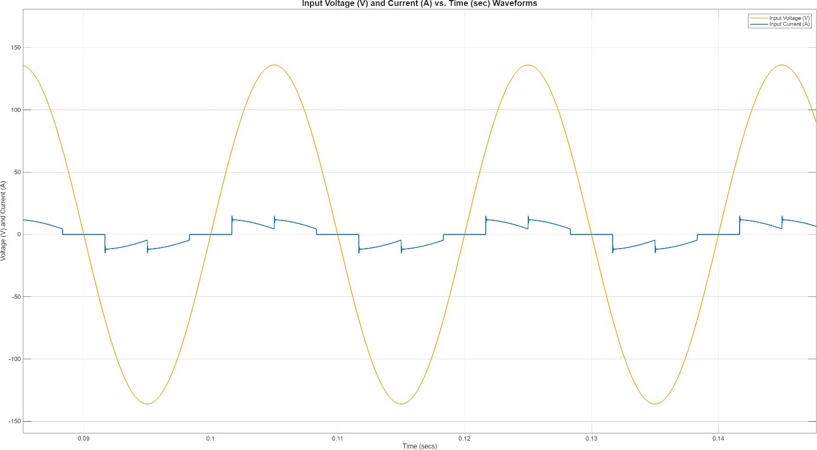
Figure 7: Input Voltage and Current Characteristics

When the input voltage waveform is observed, it can be concluded that the input voltage is a pure sinusoid, as we expected. However, the input current is highly distorted and not in a sinusoidal shape. This is because the filter output capacitor we connected to reduce the ripple. We concluded that this behavior is typical for a three-phase diode rectifier with a DC-link capacitor. Lastly, we investigated the characteristics of a single diode. The voltage and current waveforms can be seen in Figure 8.
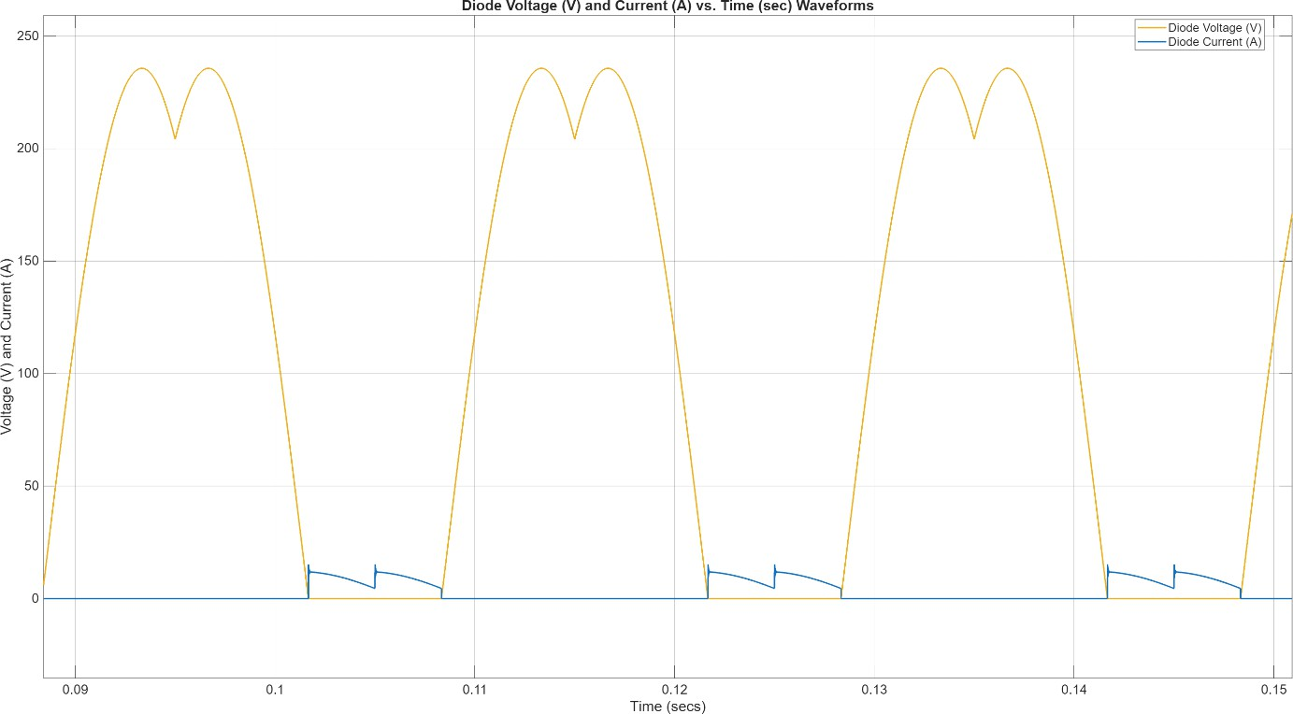
Figure 8: Diode Voltage and Current Waveforms
When the diode voltage and current waveforms are observed, it is concluded that the results coincide with the three-phase diode rectifier characteristics.

Buck Converter Simulation
For the buck converter, firstly, we calculated the values of the components, the maximum DC voltage value, the maximum duty cycle, and the maximum power. These requirements can be seen below.
𝑉_{𝑜𝑢𝑡,𝑚𝑎𝑥} = 180 𝑉, 𝐷_{𝑚𝑎𝑥} = 0.8, 𝑎𝑛𝑑 𝑃_{𝑚𝑎𝑥} = 2 𝑘𝑊 2 𝑘𝑊
𝐼_{𝑜𝑢𝑡,𝑚𝑎𝑥} = 180 𝑉 = 11.11 𝐴
𝐶ℎ𝑜𝑜𝑠𝑖𝑛𝑔 𝑎 𝑠𝑤𝑖𝑡𝑐ℎ𝑖𝑛𝑔 𝑓𝑟𝑒𝑞𝑢𝑒𝑛𝑐𝑦, 𝑓_{𝑠} = 20 𝑘𝐻𝑧

We set the maximum ripple for the output current to be 20% and for the output voltage to be 5%. Considering these limitations and the worst-case scenario, we found the inductance and capacitance values that will be used in the design. The worst case in our design is the maximum output voltage case, where the duty cycle is 0.8, as we mentioned before. Calculations for the value of the inductor are as below.

𝛥𝐼𝐿 = 𝐼𝑜𝑢𝑡,𝑚𝑎𝑥 𝑥 0.2 = 2.22 𝐴
𝑉𝑖𝑛 − 𝑉𝑜𝑢𝑡

𝑇ℎ𝑒𝑛, 𝐿 =
𝐿 =
225 − 180
𝛥𝐼_{𝐿} 𝑥 𝑓_{𝑠}
= 1 𝑚𝐻 𝑎𝑝𝑝𝑟𝑜𝑥𝑖𝑚𝑎𝑡𝑒𝑙𝑦

2.22 𝑥 20 𝑘𝐻𝑧
Thus, we concluded that we could use a 1 mH inductor in the buck converter.
Calculations for the value of the capacitor can also be seen below.
𝛥𝑉_{𝑜} = 𝑉_{𝑜𝑢𝑡,𝑚𝑎𝑥} 𝑥 0.05 = 9 𝑉
We concluded that using a 47 µF capacitor in the buck converter is applicable for our
case.
We designed the buck converter to operate within the safe limits when a DC motor is connected to its output. The simulation module for the buck converter can be seen as in Figure 9.

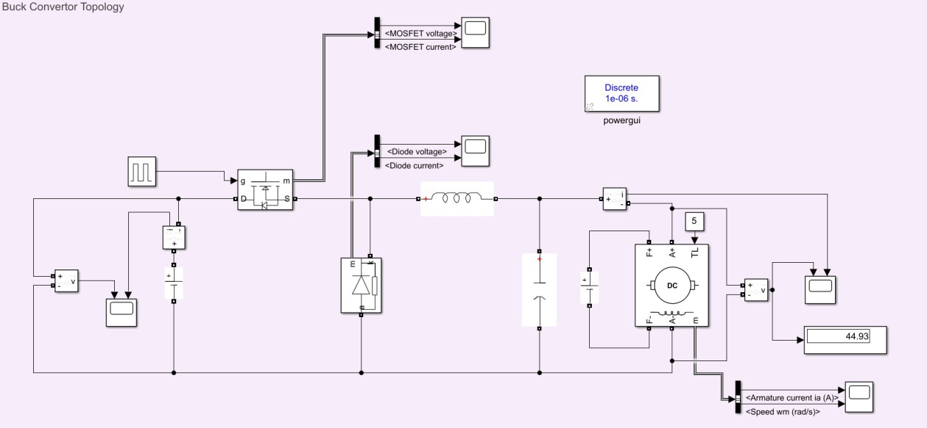
Figure 9: Buck Converter Topology

The system will be investigated with a duty cycle of 0.2 and 0.8 separately. From Figures 10 to 14, the characteristics of the design with a duty cycle of 0.2 are shown. By doing so, the characteristics of the output voltage decrease with the duty cycle, such that the buck converter topology is justified.

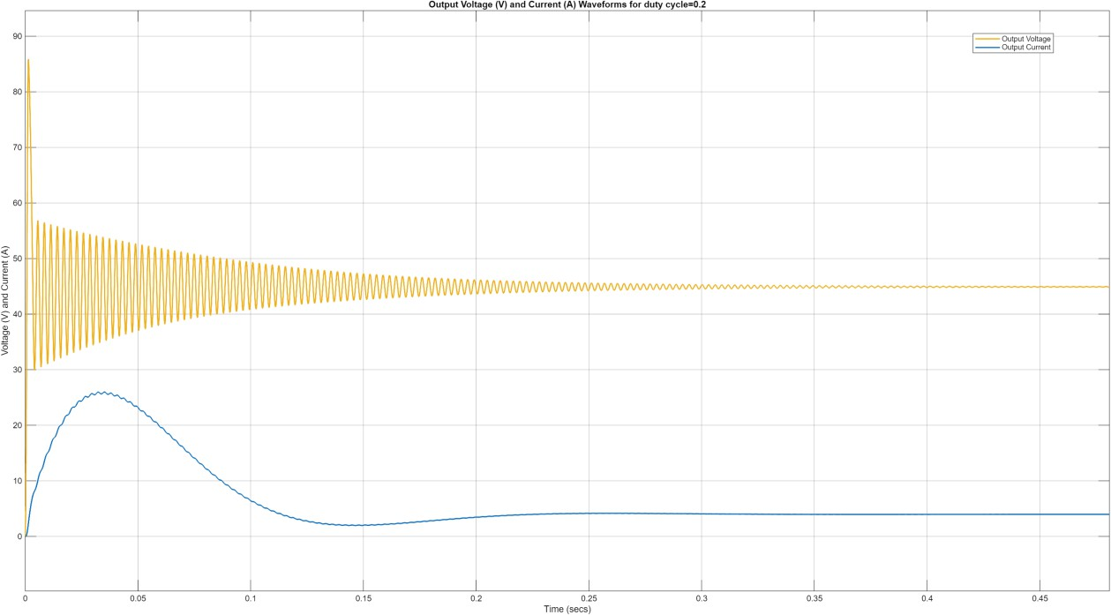
Figure 10: Output Voltage and Current Waveforms for d=0.2

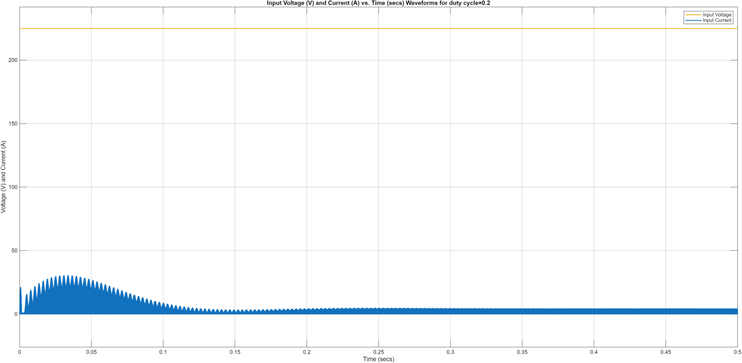
Figure 11: Input Voltage and Current Waveforms for d=0.2

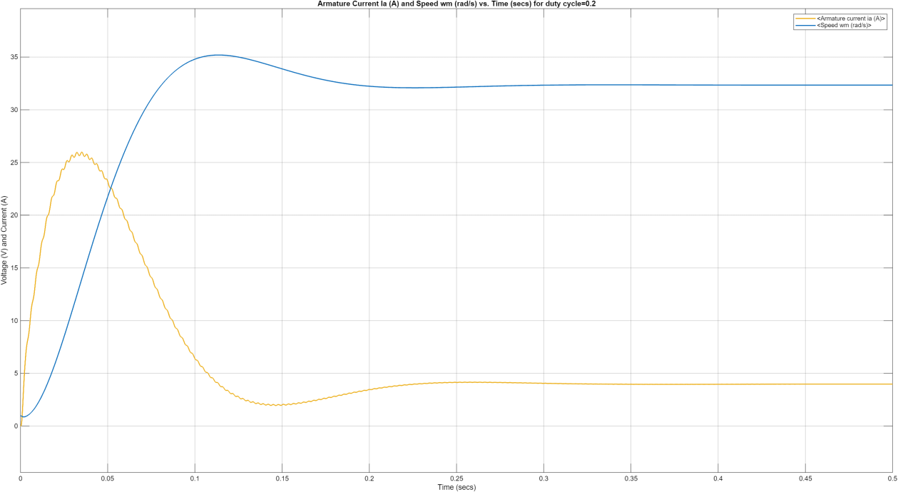
Figure 12: Armature Current and Speed of the DC Motor for d=0.2

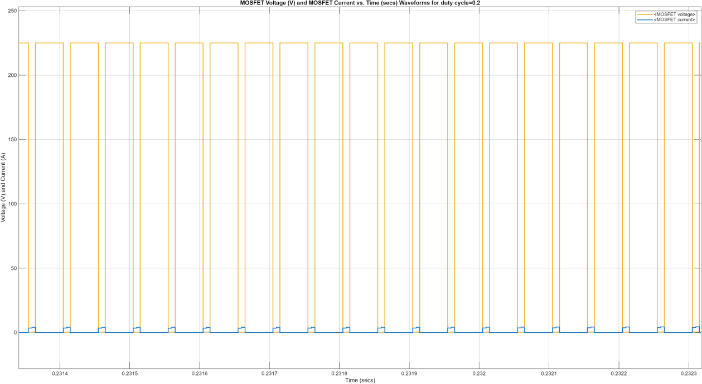

Figure 13: Switch MOSFET Voltage and Current Waveforms for d=0.2

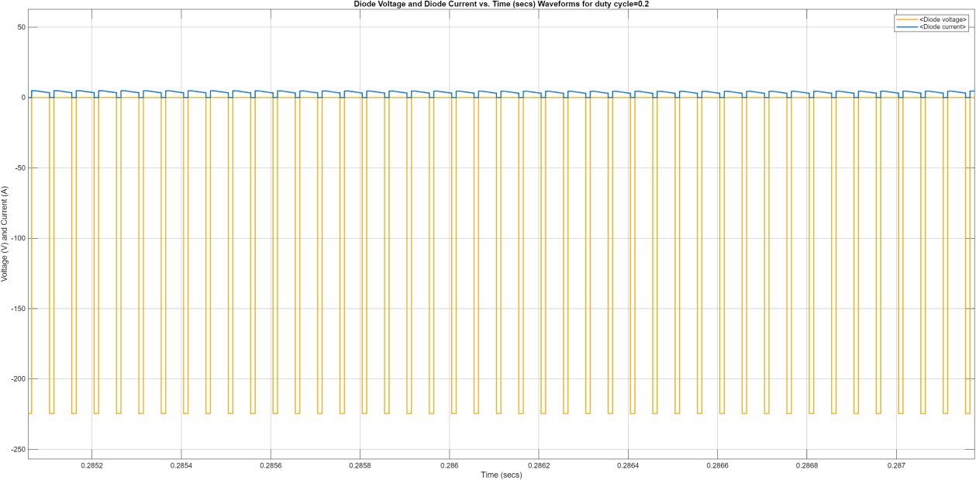

Figure 14: Diode Voltage and Current Waveforms for d=0.2

An output voltage of approximately 45 V is measured from the simulation. This justifies the buck converter operation.
After these tests, the topology is simulated using a duty cycle of 0.8. The characteristics of the design with a duty cycle of 0.8 can be observed from Figure 15 to 19.
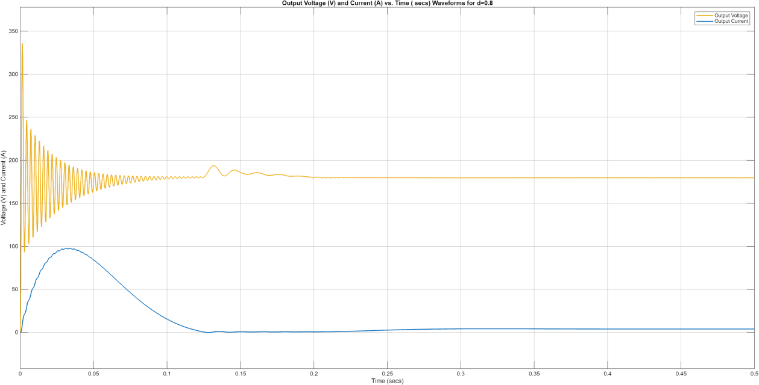
Figure 15: Output Voltage and Current Waveforms for d=0.8

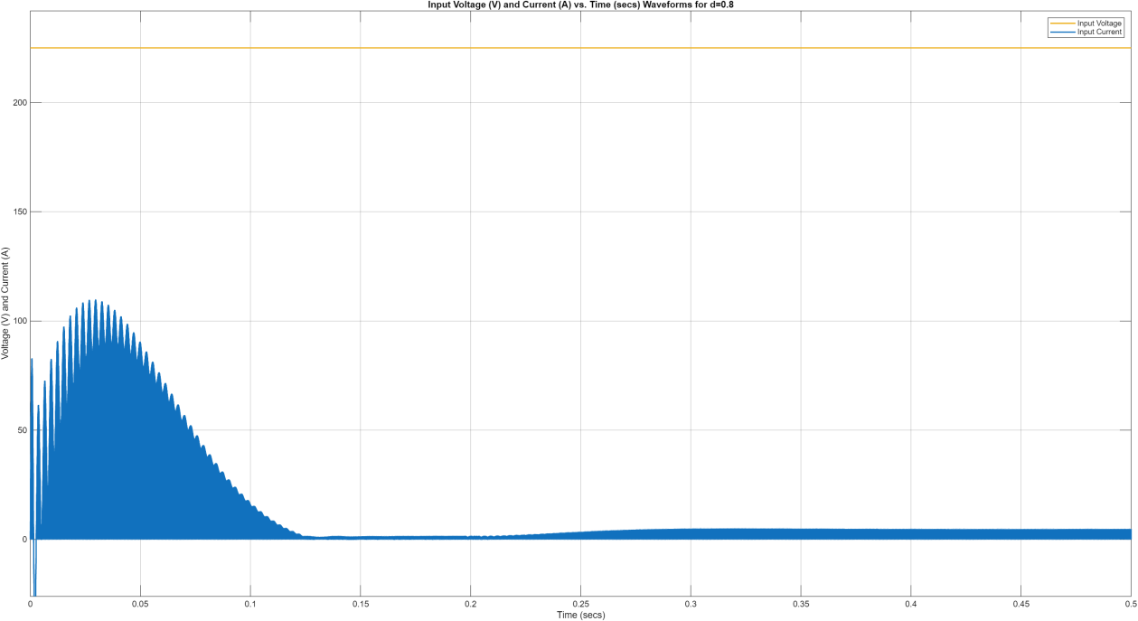
Figure 16:Input Voltage and Current Waveforms for d=0.8

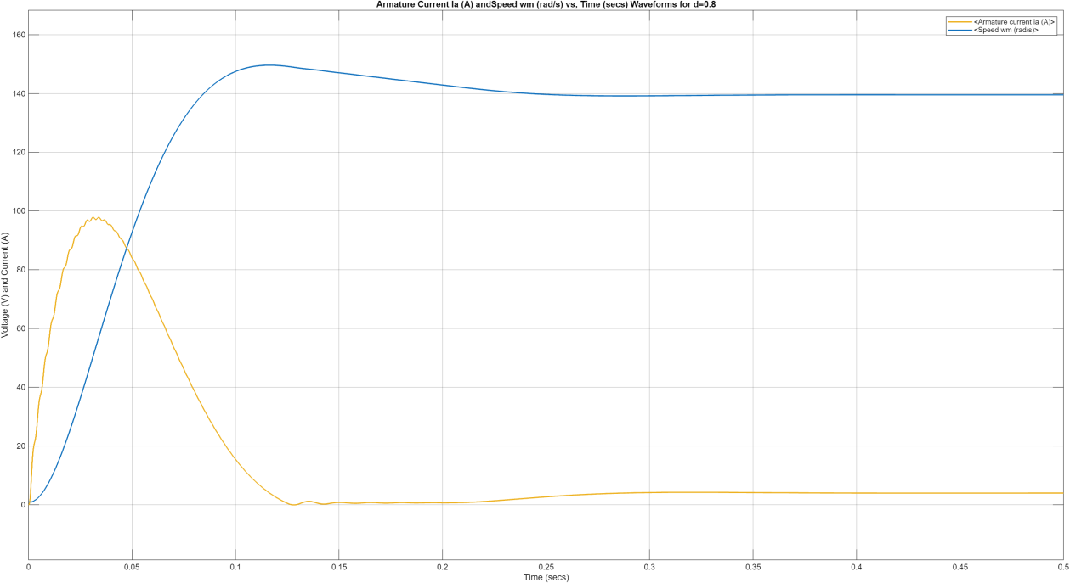
Figure 17: Armature Current and Speed Waveforms for d=0.8

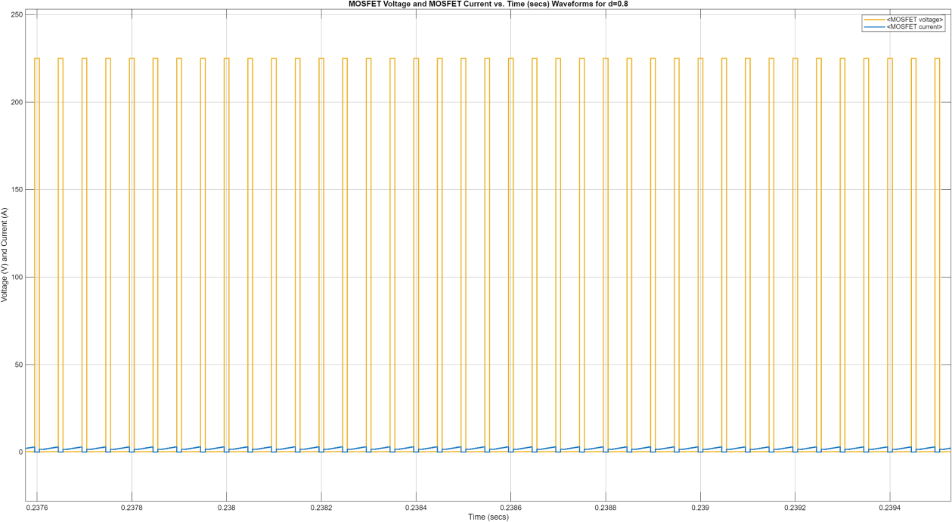
Figure 18: Switch MOSFET Voltage and Current Waveforms for d=0.8

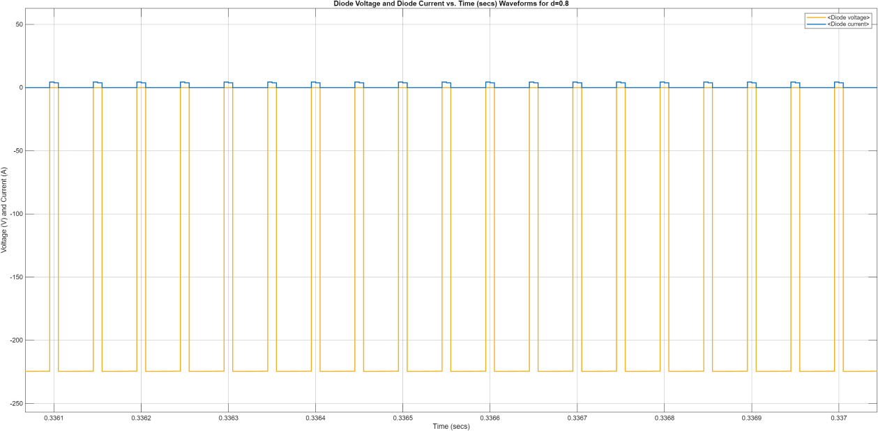

Figure 19: Diode Voltage and Current Waveforms for d=0.8
The characteristics of the buck converter with different duty ratios are observed, and it is concluded that the voltage and current ratios are directly proportional to the duty ratio. In the component selection part, the waveforms can be observed to choose the required values for the components.

Three-Phase Diode Rectifier and Buck Converter Simulation
Finally, the two topologies that are designed separately are combined to obtain a final result. The schematic of the whole topology can be seen in Figure 20.

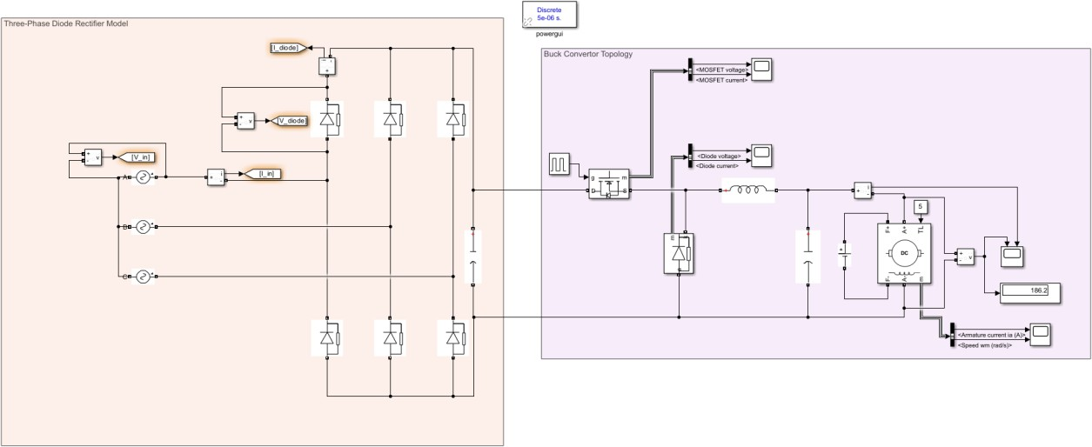
Figure 20: Rectifier and Buck Converter Topology

To choose the suitable components, we need to investigate the input and output voltage relation, MOSFET, and diode voltage and current waveforms. The indicated waveforms can be seen in Figures 21 to 23.

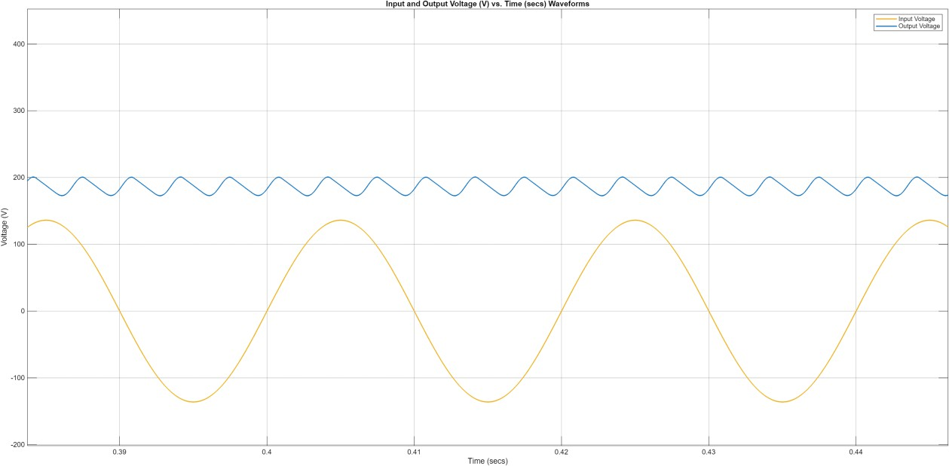
Figure 21: Input and Output Voltage Waveforms

From the output voltage, it can be concluded that the ripple of the voltage is within the applicable limits. Thus, a capacitance value for the DC-link capacitor can be specified as similar to the one we used in the simulations. Moreover, we observed that the maximum DC output is achieved using our design.
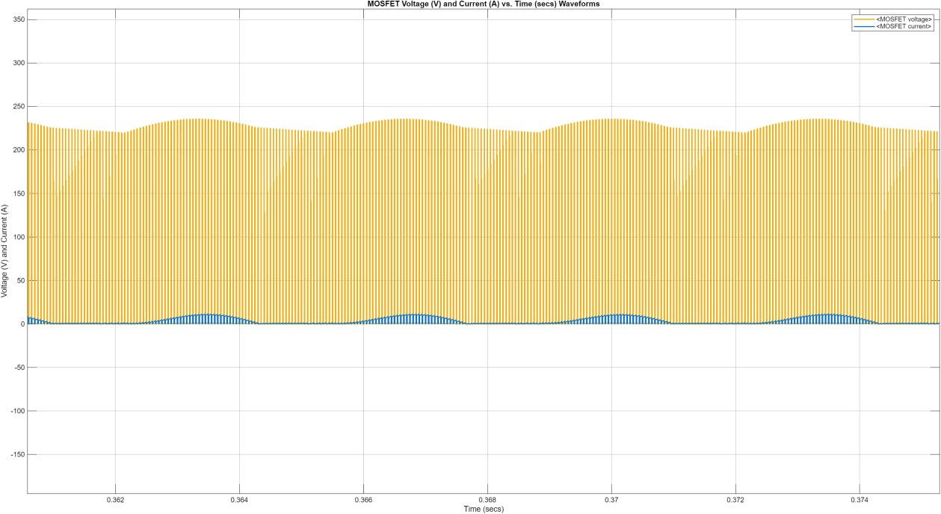
Figure 22: MOSFET Voltage and Current Waveforms

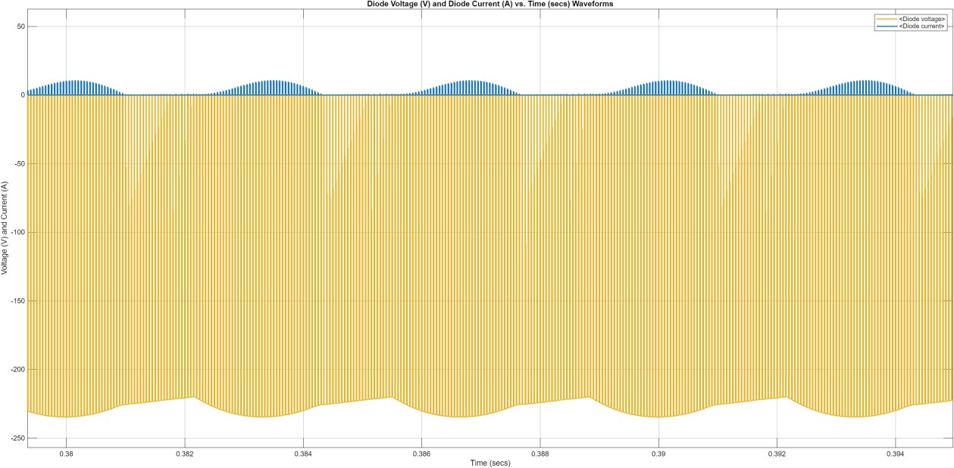

Figure 23: Diode Voltage and Current Waveforms

From the MOSFET and diode characteristics, a selection of these components will be made in the component selection part of the report.

Component Selection
This section presents the selection of the main hardware components used in the rectifier and buck converter stages. For each element, simulation results were evaluated together with analytical requirements, and components were chosen to ensure stable operation during startup, transient behavior, and steady-state load.

Rectifier
To generate the required DC-link voltage for the buck converter, a three-phase diode bridge rectifier is used. Simulation results show an average output voltage of approximately 225 V with ripple around 40 V when the input phase voltage is 136.1 V RMS.
Key Calculation
The average DC voltage is given by:

𝑉_{𝐷𝐶} =
3√2
𝜋 𝑉𝑝ℎ𝑎𝑠𝑒,𝑟𝑚𝑠 ≈ 225 V

Peak rectified voltage:

𝑉_{𝑝𝑒𝑎𝑘} = √2 ⋅ 136.1 ≈ 192.4 V

Adding ripple and transient margin:
𝑉_{𝑟𝑒𝑞𝑢𝑖𝑟𝑒𝑑} ≈ 250 − 280 V ⇒ 𝑉_{𝑟𝑎𝑡𝑖𝑛𝑔} ≥ 600 V

Current under load:
𝐼_{𝑎𝑣𝑔} ≈ 9 A, 𝐼_{𝑝𝑒𝑎𝑘} ≈ 20 − 25 A

Selected Component

→ KBPC3510 (35 A, 1000 V)
- VRRM = 1000 V
- IF(AV) = 35 A
- Surge > 300 A
Comfortably handles the peak current and voltage margin required for motor startup.

Alternative Component

→ GBPC2506 (25 A, 600 V)
- VRRM = 600 V
- IF(AV) = 25 A
- Adequate for expected stress
Suitable but offers a smaller safety margin.

Switching Device (MOSFET / IGBT)
The switch in the buck stage experiences both the full DC-link voltage and the motor/inductor current. Simulation results show peak switch voltage close to the rectifier output and current peaks during high duty-cycle operation.
Key Calculation
Peak switch voltage:
𝑉_{𝐷𝑆,𝑚𝑎𝑥} ≈ 250 − 280 V ⇒ 𝑉_{𝑟𝑎𝑡𝑖𝑛𝑔} ≥ 600 V

Switch current:
𝐼_{𝑎𝑣𝑔} ≈ 8 − 10 A, 𝐼_{𝑝𝑒𝑎𝑘} ≈ 15 − 18 A

Thus, choosing a device rated at ≥25–30 A ensures reliable operation.
Selected Component

→ STW40NM60 (MOSFET, 600 V, 40 A)
- Low RDS(on)
- High current headroom
- Efficient operation at low switching frequency
Provides strong electrical margin and runs cooler under load.
Alternative Component

→ IRFP460 (500 V, 20 A)
- Works in the observed ranges
- Requires heatsinking
Usable but with reduced voltage margin.

Free-Wheeling Diode
The free-wheeling diode conducts the inductor and motor current when the switch turns off. Its reverse voltage equals the full DC-link voltage, and it must handle the peak inductor current.
Key Calculation
Reverse voltage requirement:
𝑉𝑅 ≥ 600 V

Peak diode current:
𝐼𝑝𝑒𝑎𝑘 ≈ 15 − 18 A

A fast-recovery diode is preferred to minimize switching spikes.
Selected Component

→ STTH30L06 (600 V, 30 A)
- Very fast recovery (≈25 ns)
- High surge and thermal robustness
Ideal for limiting switching losses and improving reliability.
Alternative Component

→ MUR1560 (600 V, 15 A)
- Fast recovery (~75 ns)
- Moderate current rating
Acceptable but with less current overhead.

Capacitor
Capacitors are grouped together rather than split into DC-link and output sections.
Therefore, a combined capacitor section is used here.
Simulation showed that using 100 µF results in ~40 V ripple. To stabilize the DC-link, a higher capacitance is required.
Key Calculations
𝐶_{𝐷𝐶−𝑙𝑖𝑛𝑘} ≈ 150 − 220 𝜇𝐹, 𝑉_{𝑟𝑎𝑡𝑖𝑛𝑔} ≥ 400 V

For the buck output:
𝐶_{𝑜𝑢𝑡} ≈ 47 𝜇𝐹, 𝑉_{𝑟𝑎𝑡𝑖𝑛𝑔} ≥ 250 V

Selected Components
→ 220 µF / 400 V Electrolytic (DC-Link)
- Adequate ripple handling
- Stabilizes rectifier output
Provides smoother DC-link for the buck stage.
→ 47 µF / 250 V Film Capacitor (Output)
- Low ESR
- High ripple endurance
Improves voltage ripple performance at the motor.

Inductor
The inductor controls the current ripple of the buck converter. Based on the ripple target (~20%), switching frequency (~1 kHz), and D = 0.8, the required inductance is:
𝐿 ≈ 1 mH

Saturation current requirement:
𝐼_{𝑠𝑎𝑡} ≥ 15 − 20 A

Selected Component
→ 1 mH / 20 A Ferrite Core Inductor
- Low AC loss at 1–2 kHz
- High saturation margin
Matches the simulated current ripple profile.
Alternative Component
→ 1 mH / 15 A Iron Powder Inductor

- Stable performance at low frequencies
Suitable but slightly lower saturation limit.

Thermal Analysis
Thermal performance is a critical aspect of the hardware implementation, especially because the system drives an inductive load and may experience short periods of high inrush current during startup. In this section, conduction and switching losses are calculated for the selected devices, and their expected junction temperatures are evaluated under worst-case operating conditions.

Switching Device (MOSFET / IGBT)
The selected MOSFET (STW40NM60) or IGBT (if preferred) must handle both DC conduction and switching losses. Simulation results show an average inductor current of approximately I_on = 10 A, with duty ratio D = 0.8 at high output voltage.
Conduction Loss
For MOSFET:
𝑃_{cond} = 𝐼² 𝑅
rms
𝐷𝑆(𝑜𝑛)

Using:

𝐼_{rms} ≈ 10 A, 𝑅_{𝐷𝑆(𝑜𝑛)} ≈ 0.07Ω
𝑃_{cond} ≈ 10² ⋅ 0.07 = 7 W

For IGBT (if used), conduction loss follows:
𝑃cond = 𝑉𝐶𝐸(𝑠𝑎𝑡) ⋅ 𝐼𝑜𝑛 ⋅ 𝐷

Using datasheet values:
At 25°C:
𝑃_{cond} = 1.5 ⋅ 1.1 ⋅ 0.8 = 1.32 W

At 175°C:
𝑃_{cond} = 1.9 ⋅ 1.1 ⋅ 0.8 = 1.67 W

Switching Loss
For MOSFET or IGBT:
𝑃sw = (𝐸𝑜𝑛 + 𝐸𝑜𝑓𝑓) ⋅ 𝑓𝑠𝑤

At 25°C:

𝐸_{𝑜𝑛} = 0.40 mJ, 𝐸_{𝑜𝑓𝑓} = 0.30 mJ, 𝑓 = 1kHz
𝑃_{sw} = (0.40 + 0.30) ⋅ 10⁻³ ⋅ 1000 = 0.70 W

At high temperature (125°C–175°C):
𝐸_{𝑜𝑛} = 1.0 mJ, 𝐸_{𝑜𝑓𝑓} = 1.1 mJ
𝑃_{sw} = (1.0 + 1.1) ⋅ 10⁻³ ⋅ 1000 = 2.1 W

Total Losses
At 25°C:
𝑃_{total} ≈ 7.0 + 0.7 = 7.7 W

At high temperature:
𝑃_{total} ≈ 7.0 + 2.1 = 9.1 W

Junction Temperature Estimation
Assuming a small heatsink gives:
𝑅_{𝜃𝐽𝐴} ≈ 8∘𝐶/𝑊

Then temperature rise is:

At 25°C environment:

Δ𝑇 = 7.7 ⋅ 8 ≈ 62∘𝐶
𝑇_{𝐽} ≈ 25 + 62 = 87∘𝐶

At worst case:
𝑇𝐽 ≈ 25 + 9.1 ⋅ 8 = 97∘𝐶

This is well within the MOSFET’s 150°C maximum junction temperature, confirming safe operation.

Bridge Rectifier
The bridge rectifier sees the full line current and experiences large but short surge currents during startup. The peak forward drop per diode is around 1.2–1.3 V, and two diodes conduct at any time.

Conduction Loss

𝑃 = 2 ⋅ 𝑉𝑓 ⋅ 𝐼𝑎𝑣𝑔
𝑃 = 2.4𝑉 ⋅ 9𝐴 ≈ 21.6𝑊

This is a worst-case continuous dissipation assumption.
Thermal Rise Without Heatsink
𝑅_{𝜃𝐽𝐴} ≈ 50 K/W(typical for bridge modules)

𝑇_{𝐽}

= 𝑇𝑎𝑚𝑏
+ 21.6 = 25 + 0.43 ≈ 25.4∘𝐶
50

This formula seems too low because it does not account for thermal resistance per diode path, but even considering conservative values, the junction temperature remains below limits as long as the module is attached to a metal plate.
Surge Current Case (Startup)
Peak surge >300 A lasts only a few ms → heating negligible due to large thermal time constant.
Conclusion:
Mount the bridge rectifier on an aluminum plate or PCB copper plane → safe under all expected loading conditions.

Free-Wheeling Diode
The selected diode (STTH30L06) must handle high current pulses and block the full DC-link voltage.

Switching Loss

1
𝑃_{sw} = 𝑉_{𝑅} ⋅ 𝑓_{𝑠𝑤} ⋅ 𝑡_{𝑟𝑟} ⋅ 𝐼_{𝑟𝑟} ⋅ 2

At 25°C:
235 ⋅ 1000 ⋅ 25ns ⋅ 2.5𝐴 ⋅ 0.5 = 7.344 mW

At 100°C:
235 ⋅ 1000 ⋅ 70ns ⋅ 4.5𝐴 ⋅ 0.5 = 37.013 mW

Switching losses are therefore very small. Conduction Loss

Using forward voltage at 30 A:

𝑃_{cond} = 𝑉_{𝐹} ⋅ 𝐼_{𝐹} ⋅ 𝐷
𝑃_{cond} = 2.51 ⋅ 25 ⋅ 0.8 = 50.2 W

At high temperature (150°C):
𝑃_{cond} = 1.61 ⋅ 25 ⋅ 0.8 = 32.2 W

Thermal Requirement
Even though 30 A conduction is worst-case (rare in continuous operation), the diode requires:
- A small dedicated heatsink OR
- Mounting to a metal plate
to stay below its 150°C junction limit.

Conclusion
In this project, a controlled rectifier circuit was successfully designed to drive a 5.5 BHP DC motor. After evaluating multiple topologies, the team selected the Three-Phase Diode Rectifier with a Buck Converter due to its cost-effectiveness, control simplicity, and low output ripple.
Detailed simulations confirmed that the design meets the project specifications. With an input phase voltage of approximately 136.1 V RMS, the system generates the required DC- link voltage to drive the motor up to 180 V DC. The analysis of the components, including the MOSFET and free-wheeling diode, verified that the system will operate safely within thermal limits under load. Consequently, the proposed design offers a robust and efficient solution
for the defined industrial application.

